Game Logic Team Documents

In the iteration 2 , although no new feature requests were there for the Game Logic module by the other groups, significant improvements were implemented internally to enhance functionality and maintainability. A key change was made to the CheckersMove class by introducing a static nested Move class. This new structure allows each move to store its destination row and column along with a list of captured positions, which was not possible with the previous logic. The update supports both single and multi-jump moves by encapsulating captured piece coordinates in a structured way. This change improves how the game handles complex move sequences and paves the way for future features like move replay or undo functionality.
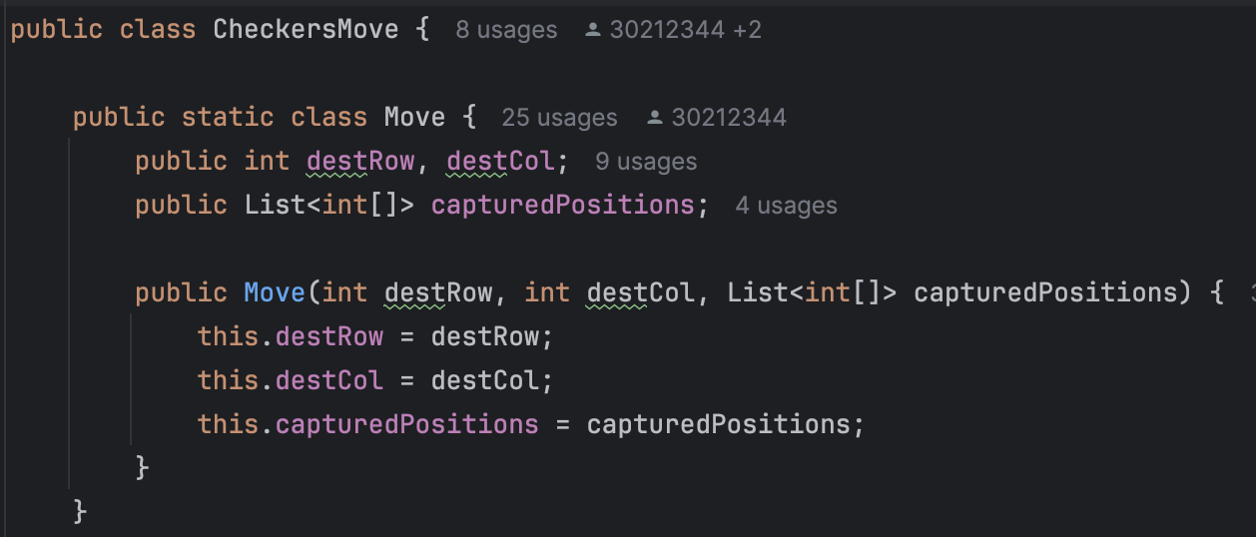
Additionally, the planning document was revised to reflect the full scope of the project rather than just Iteration 1. The original version was limited and lacked alignment with the complete development cycle. The updated version includes detailed timelines, responsibilities, and goals across all project phases, ensuring that the planning reflects actual progress and deliverables.

Use Case Diagrams:
Following is the annotated diagram received from Iteration 2 feedback:
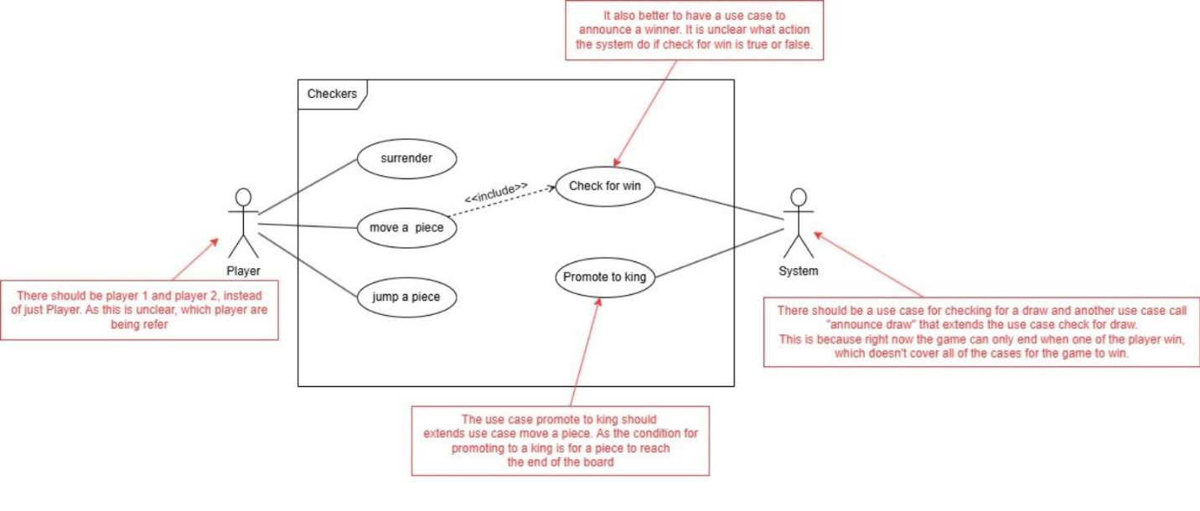
Updated Diagram:
Added a note to make the player actor clear. Added use cases for announcing winner, check for draw, and announce draw. Created a new extend relation from “move a piece” to “promote to king”.
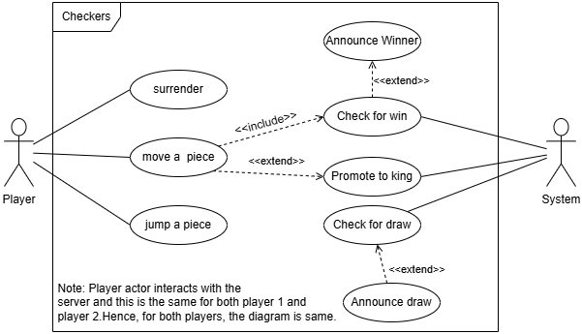
Similarly, use case diagrams for tictactoe and connect4 are also updated.

